Run a background task with Web Job

1. Create a sample .NET console application

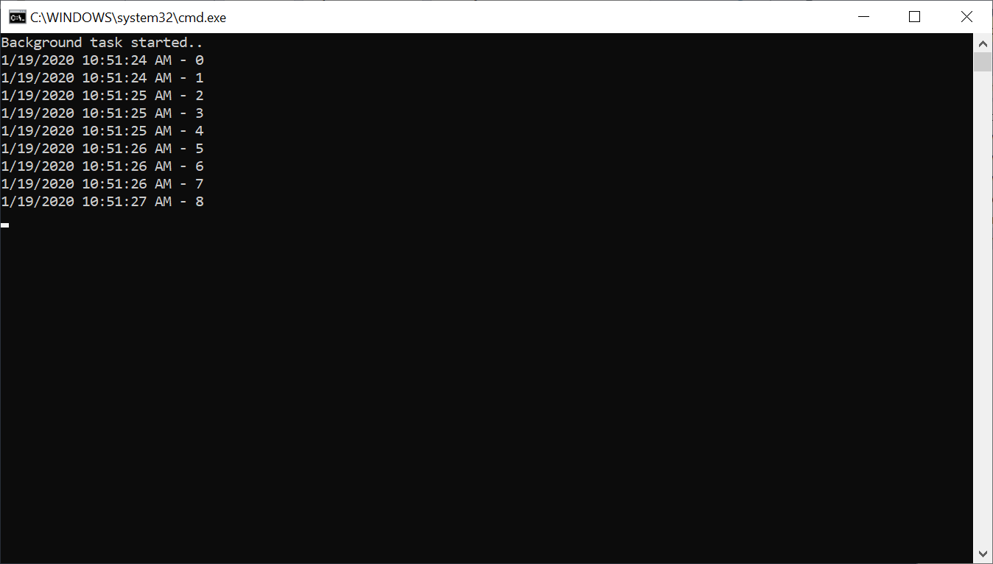

1. Azure Portal 🡪 Open any existing App Service 🡪 Web Job

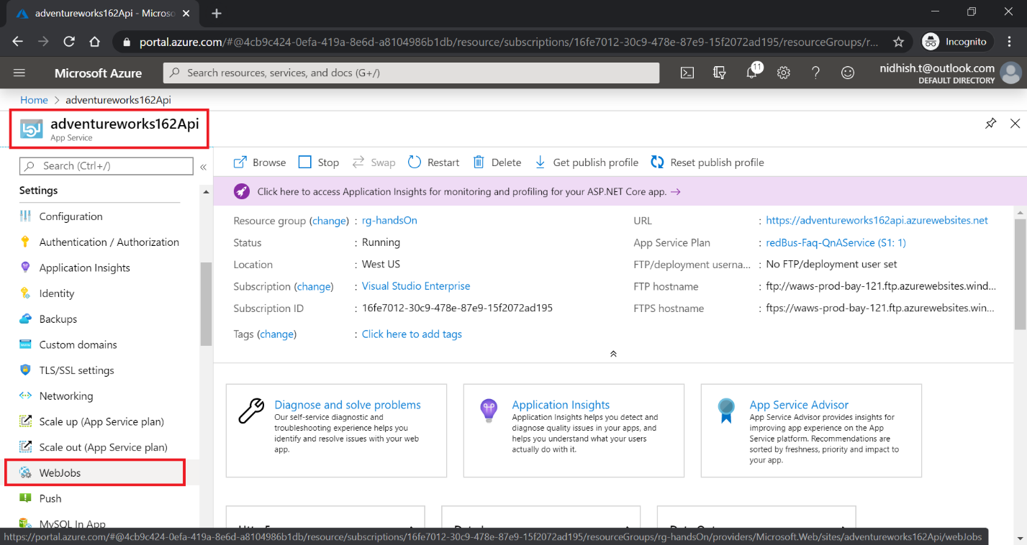

1. Add Web Job

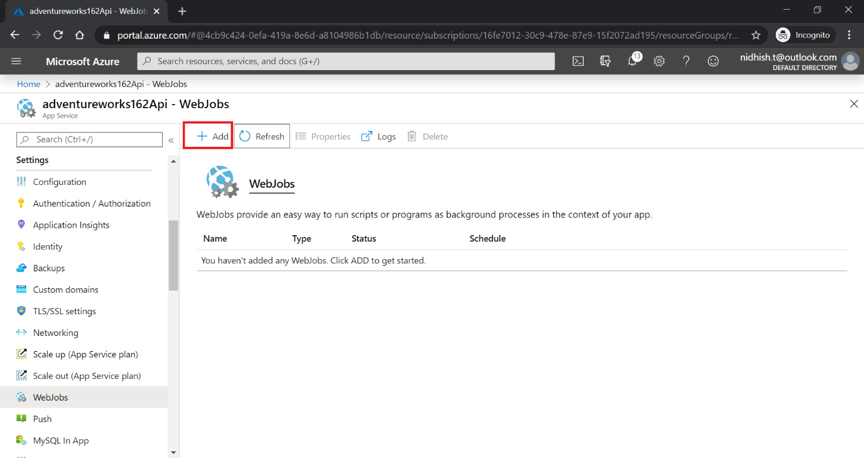

webjob-adventureworks

1. Configure Web Job

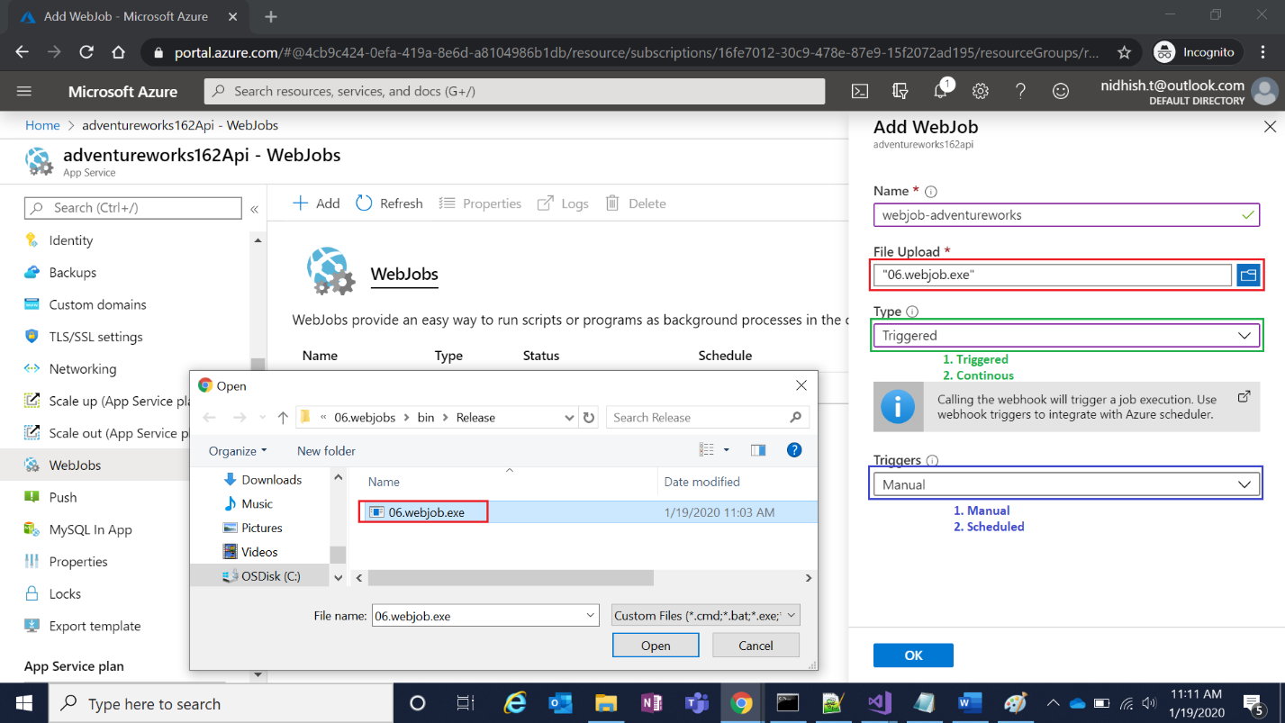

**Note**: Browse 06.webjob.exe from local machine

1. Newly added Web Job is listed here:

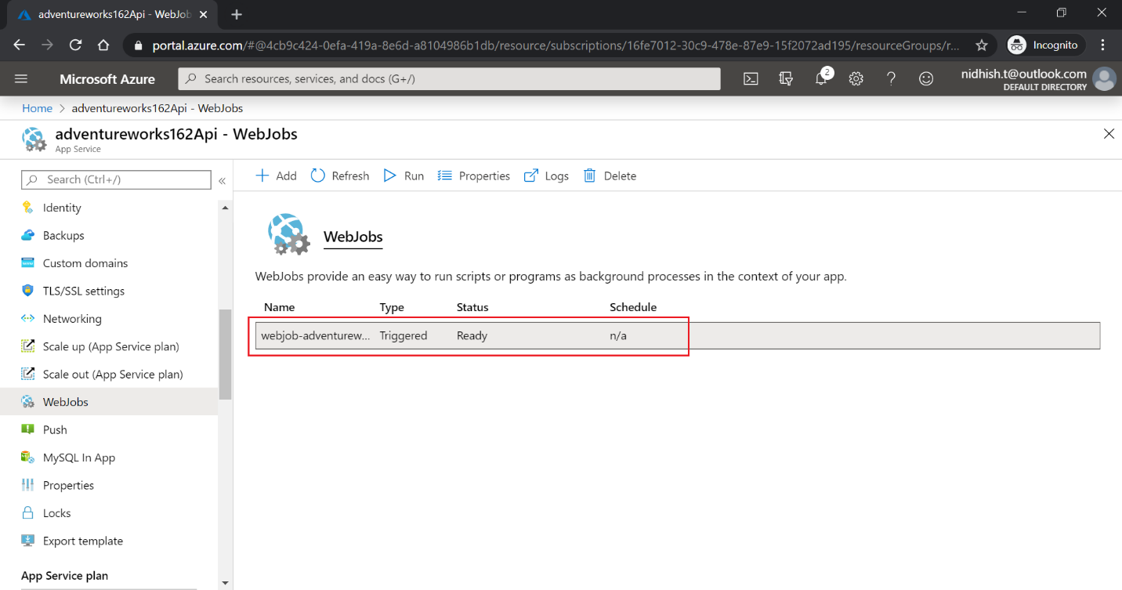

1. Run the Web Job

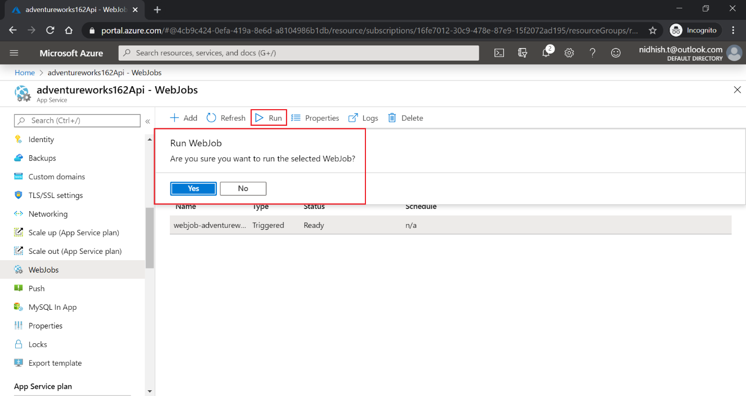

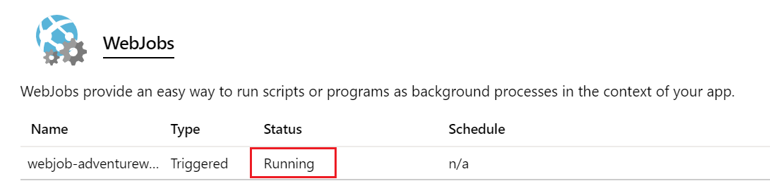

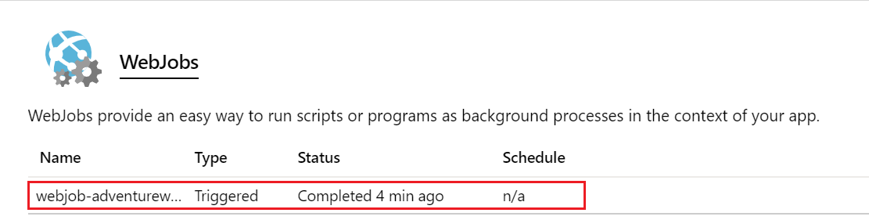

1. Click on the Logs for details

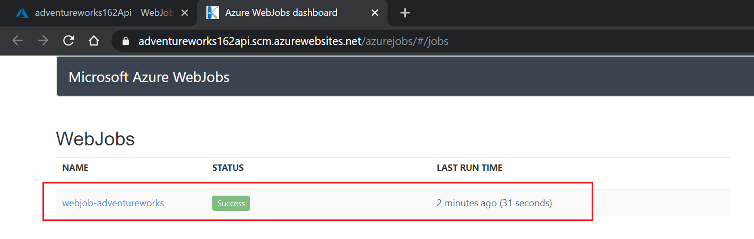

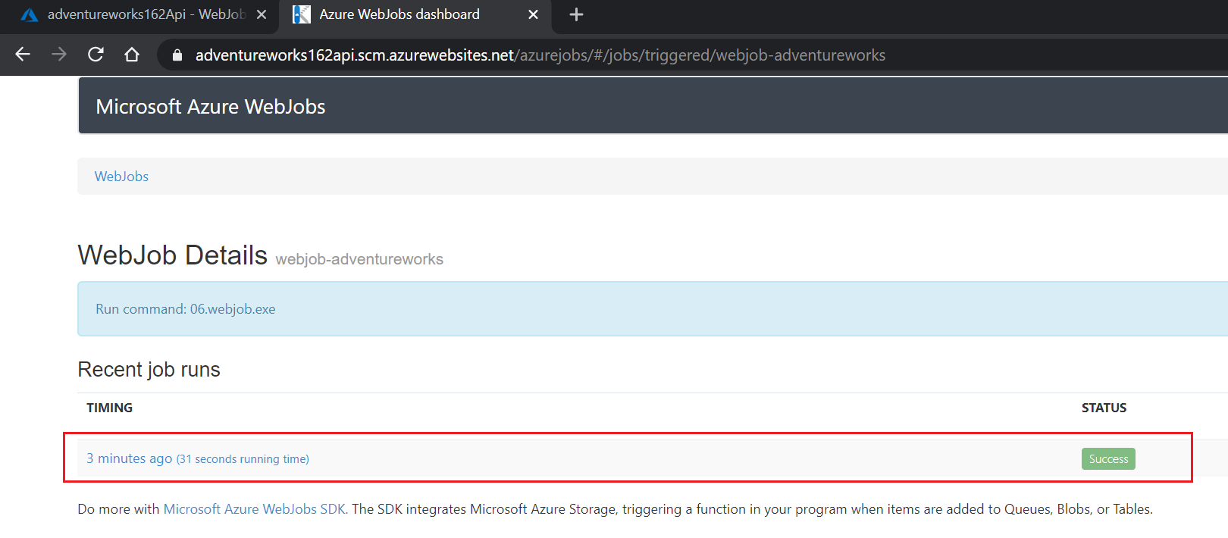

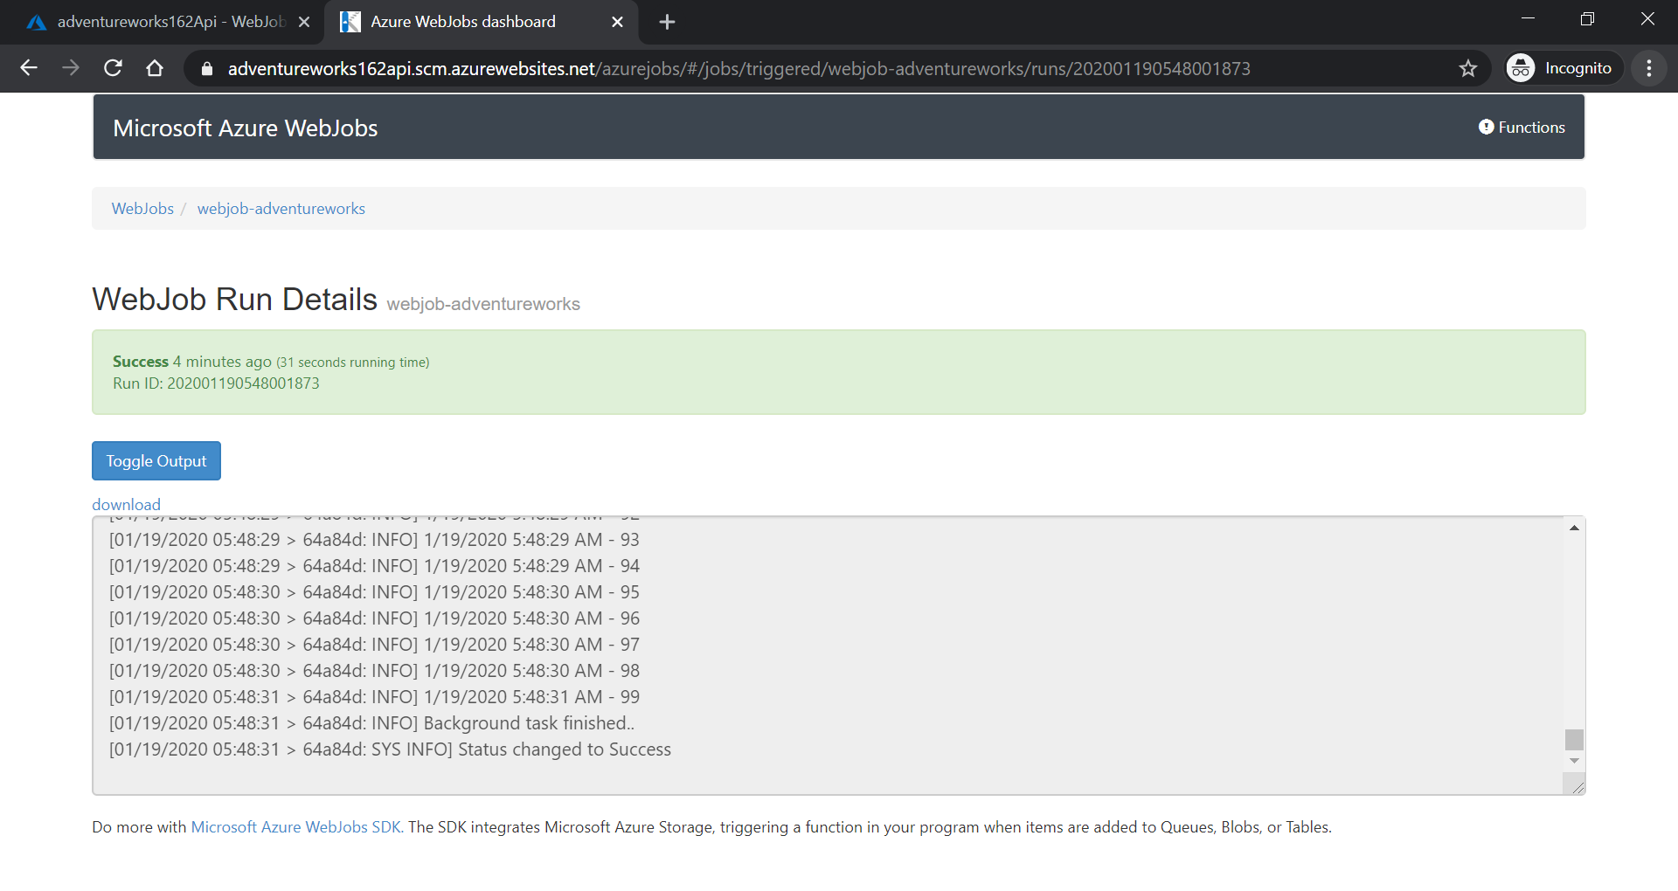

1. These log files are in below path:

D:\home\data\jobs\triggered\webjob-adventureworks\

